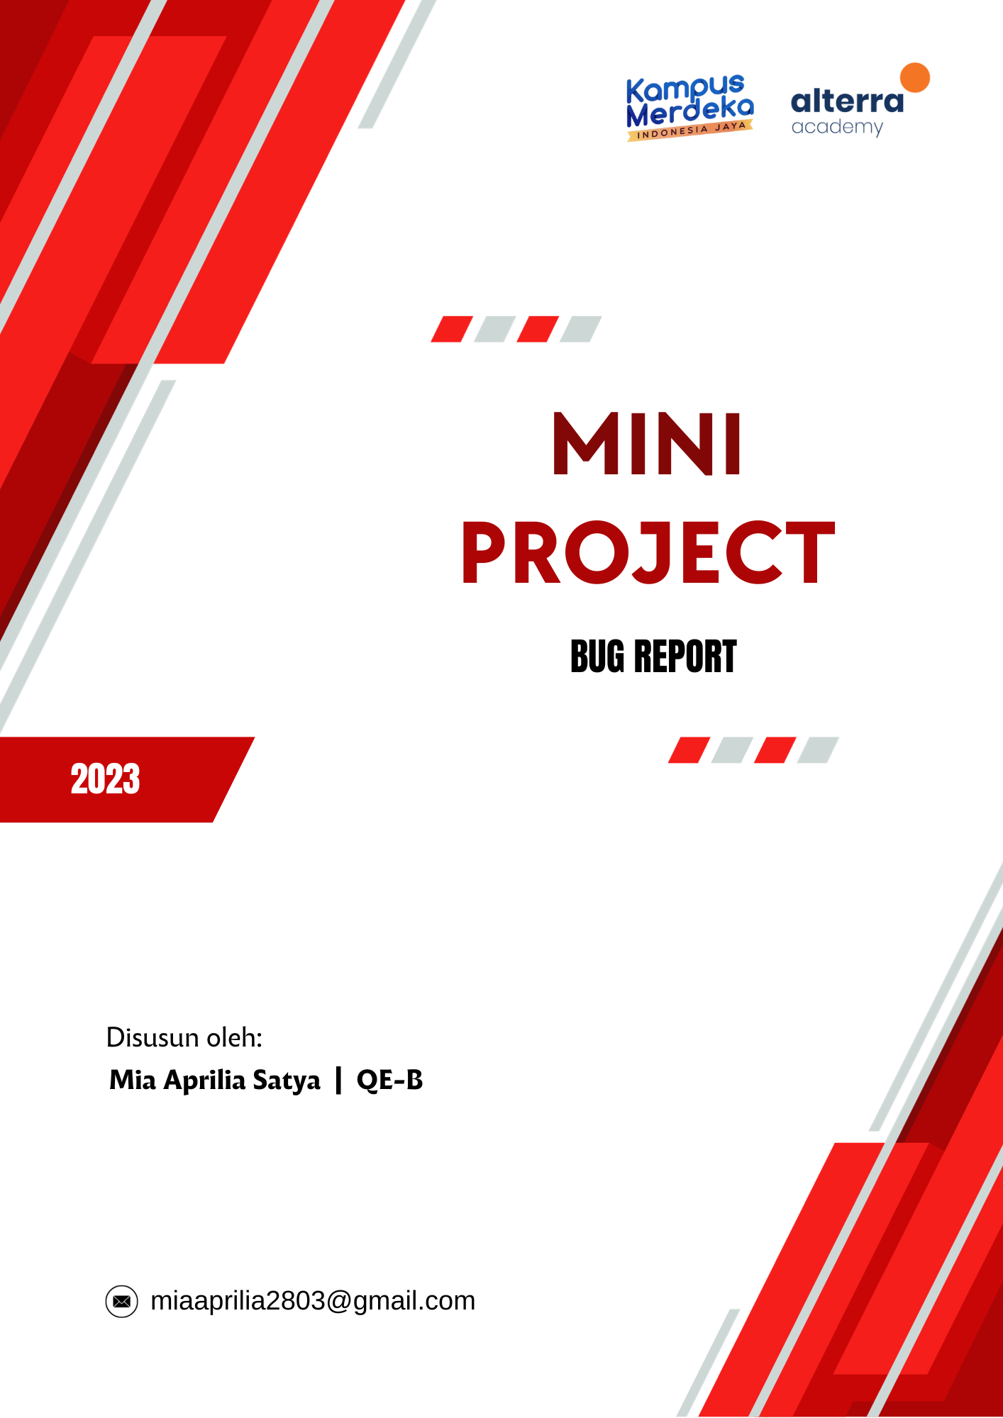**ALTA SHOP**

***PLATFORM RESTFULL API BUGS***

1. ***Authentication (Register)***

|  |  |
| --- | --- |
| Defect ID | API01 |
| Test Case ID | ASA-14 |
| Issue | Can register if the email request format is no appropriate (e.g.: missing @) |
| Report Date | 29 Oktober 2023 |
| Test Priority | Medium |
| Expected Result | 1. I received status code 400 Bad Request in request to register user 2. I received the error message "unknown email format" response |
| Actual Result | 1. I received status code 200 OK register user 2. I received register user data response |
| Report To | Backend Developer |

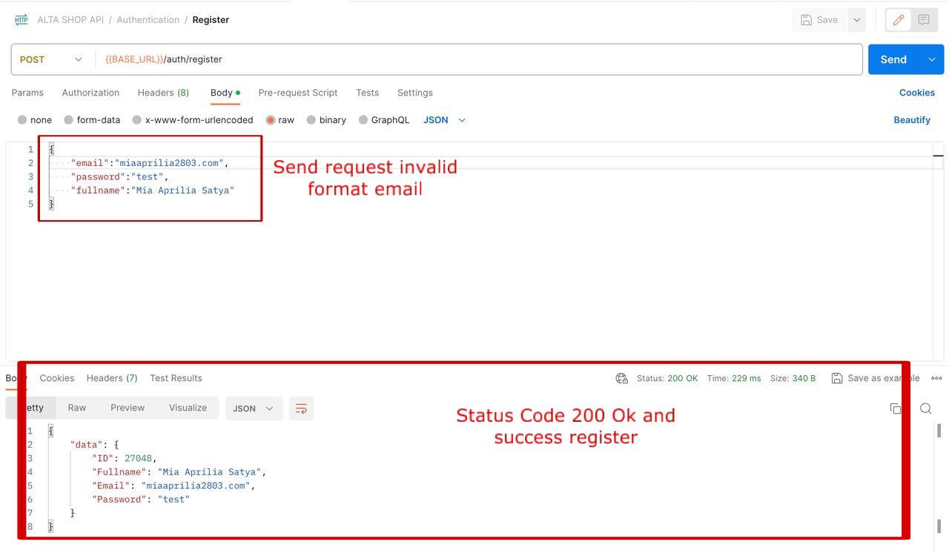

**ALTA SHOP**

***PLATFORM WEB UI BUGS***

* 1. ***Authentication Feature (Register)***

|  |  |
| --- | --- |
| Defect ID | WEB01 |
| Test Case ID | ASW-6 |
| Issue | Can register if the email request format is no appropriate (e.g.: missing @) |
| Report Date | 29 Oktober 2023 |
| Test Priority | Medium |
| Expected Result | 1. I see error message appear"unknown email format" in register page |
| Actual Result | 1. I successfully Register 2. User redirect to login page |
| Report To | Backend Developer |

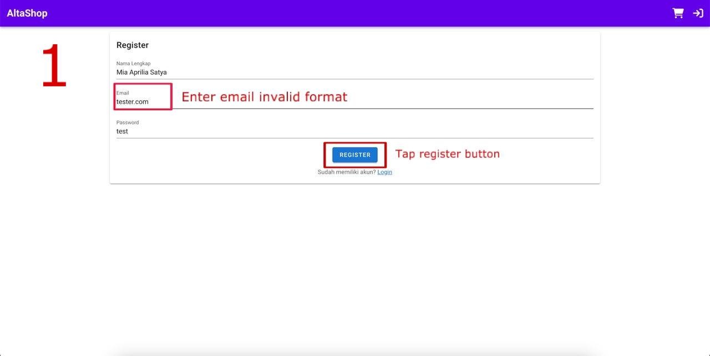

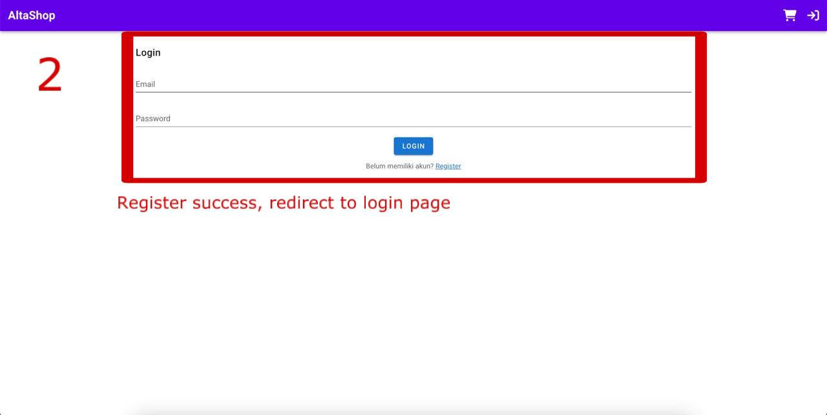

* 1. ***Product Feature***

|  |  |
| --- | --- |
| Defect ID | WEB02 |
| Test Case ID | ASW-18 |
| Issue | Can’t be rating product in details page |
| Report Date | 29 Oktober 2023 |
| Test Priority | High |
| Expected Result | 1. I can see the submitted ratings |
| Actual Result | 1. I don't see any changes to the ratings that have been submitted 2. Ratings can't be changed via the website |
| Report To | Backend Developer |



